Validation of the codes written.

It has 4 coded html files namely:

* Index.html
* Aboutme.html
* SkillSet.html
* ContactInformation.html
* Styles.css

**Index.html:**

No Errors or Warnings

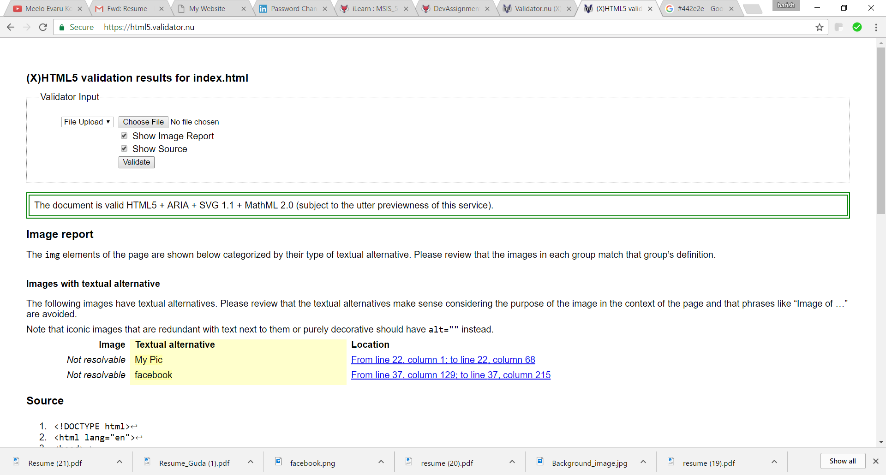

**Aboutme.html:**

No Errors or Warnings

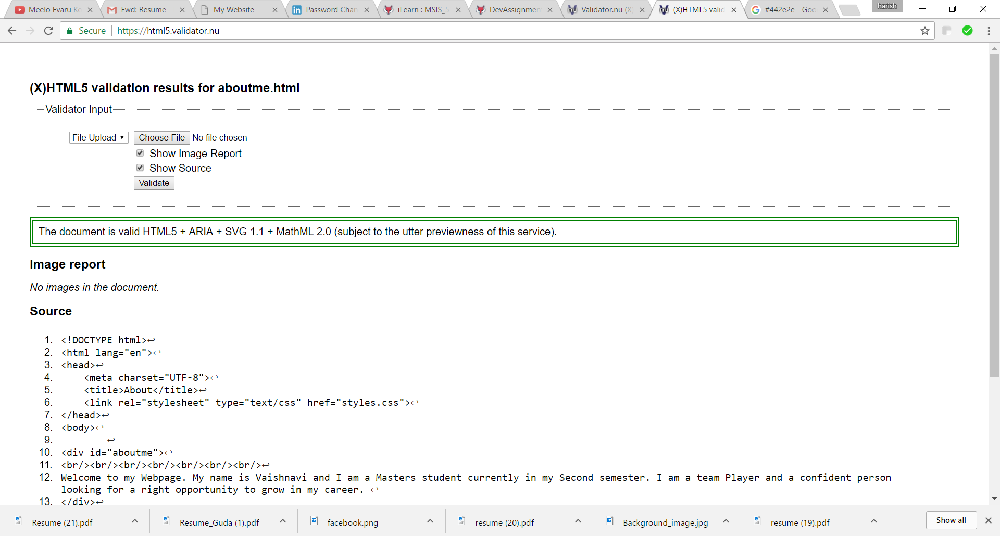

**skillSet.html:**

No Errors or Warnings

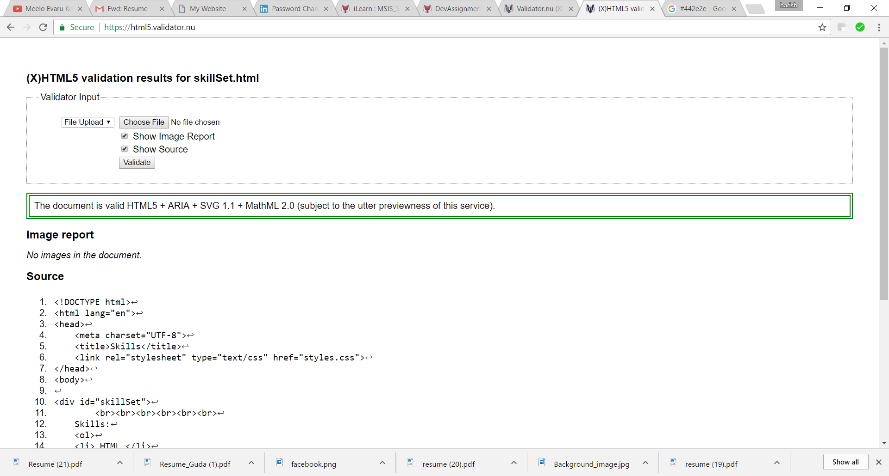

**ContactInformation.html:**

No Errors or Warnings

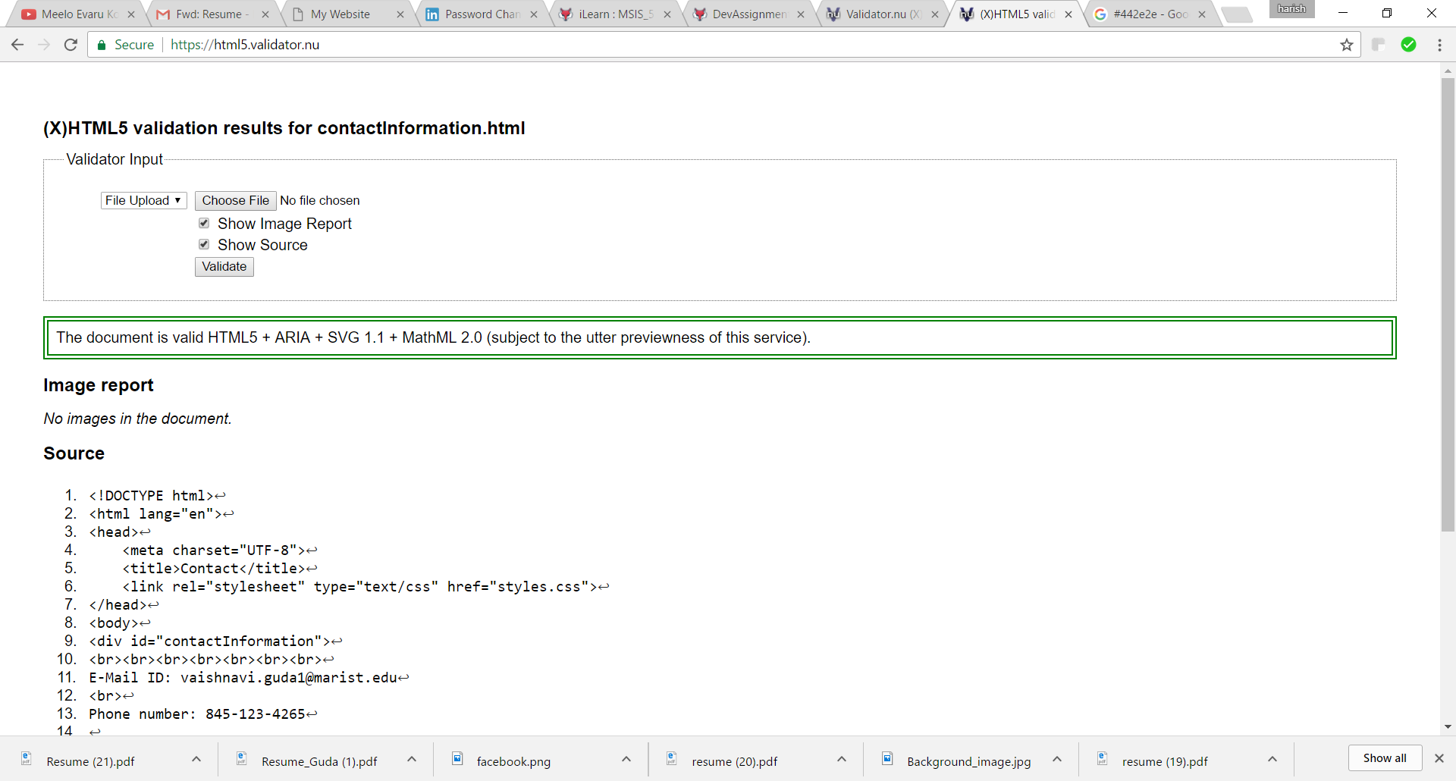

**Styles.css:**

No Errors or Warnings

